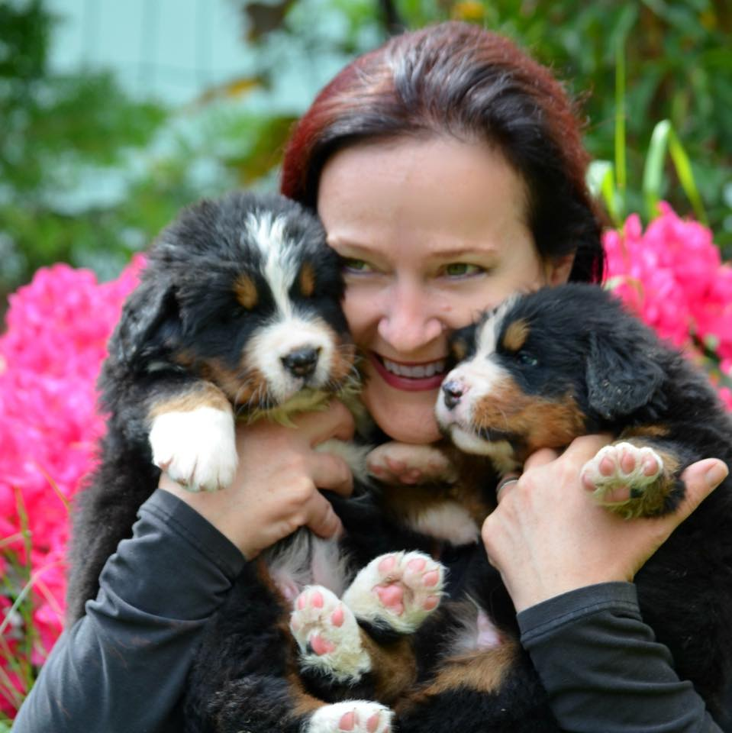
Judge Information

Judge Name: | Andrea Maret
Location: | Fully, Switzerland
Kennel Name: | De Marais Champagne
Website: | www.maraischampagne.ch
Types of Shows: | Conformation
Type of Breeds | Bernese mountain dog, Appenzell cattle dog, Great swiss mountain dog
Biography

Together with my husband Christophe, I’ve been breeding Bernese Mountain dogs under the kennel name “de Marais Champagne” since 1999. Our goal is to improve the breed in health and in structure. We bred several show champions, but also therapy dogs. For the past 16 years, I have taken my dogs into schools every week as part of the Prevent a Bite program to teach kids the correct behavior and how to interact with dogs. We have been successful in regularly producing the club champion winner – a dog who makes the most points on all shows in Switzerland during one (1) year. During the last Swiss Specialty Show, our female Harmonie de Marais Champagne was awarded BOS.
In addition to our breeding program, I am very active in the Bernese Mountain Dog Club of Switzerland . I have served as the president of the breeding committee since 2005, with responsibility for the studbook, shows judges, evaluating dogs for behavior, and serving as a consultant for breeders. I am the club contact for the health committee, and we collaborate and work with scientists in their research to improve the quality and health for the breed. I am also a member of the central committee (Board) of the Bernese Mountain dog Club of Switzerland.
I am a certified FCI judge with upcoming assignments in Norway in June 2020, in Canada in August and France in October 2020. I have also judged multiple international shows in Switzerland, and the Swiss Bernese Mountain Dog Show in 2018.

